DESIGNING & BUILDING FLOATS
BY CHUCK CUNNINGHAM
Last month we discussed some of the problems and solutions when flying from water with float equipped R/C aircraft. This month let's take a look at floats, what size to use, how to build them, how to install them, and how to enjoy them. There are a number of commercial floats on the market using all types of materials; built-up balsa, fiberglass, molded plastic, and Styrofoam. With so many types to choose from, why worry about building your own? First, you can size your floats exactly to the size of your aircraft. Second, Styrofoam floats are very easy to build, and third, they we very inexpensive.
Last month we very briefly touched on the subject of size. The length of the fuselage is the main factor in determining the length of the float. For most R/C models measure the distance from the back of the prop to the hinge line of the elevator. The length of each float should be at least 75% of this length and not more than 80%; I like 75% best.
Make a scale drawing of the float that you are going to use by applying the dimensions on the float drawings. For example, let's assume that you're going to equip your .60 size model with floats. And let's also assume that the fuselage length is 48" and the span is 66", and that the wing is a rectangular planform with a chord width of l2". Further, let's assume that your model balances at 3 3/4" back from the leading edge of the wing and that the distance from the balance point of your model to the back of the prop is l3".
Working from our design data we find that the overall float length should be 36". From the step forward, the length is 53% of the overall length or, in our case 19". Locating the step 1/2" behind the balance point gives us a float that extends past the prop about 2 1/4 - 2 1/2". The aft end of the float is 47% of the total length, or 17". If you have a model with a very long nose, or the wings are swept back you will probably have to make your floats longer in the nose to accommodate the configuration of your aircraft. Leave the rest of the float design alone, just add what is needed to the nose length. The step height should be roughly 25% of the overall float height.
Long time readers will recognize that I am recycling the same drawing and design information I have given to you in the past, but I know from long experience that many of the current readers are new to the hobby and may not have seen this information before. Many of you older readers might just now be thinking about flying from water also, and have no idea where or when the last time this information was presented, so here it is again.
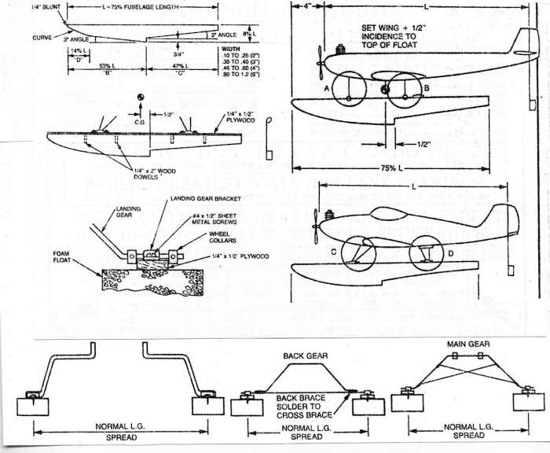
These dimensions will hold true for any type of float construction. Making the floats from Styrofoam is quick and easy. We are not going to make templates for hot wire cutting of the foam. Instead, we are going to cut it with a band saw using a normal saw blade of 14 or 15 teeth to the inch. Simply draw the pattern on the side of the foam block, cut it out with the band saw, and there you have the hardest part done. If you do not have access to a band saw you can achieve the same results using a hand saw or a coping saw. Anything but a band saw will require quite a bit of sanding. Use a fine grit sandpaper on a large sanding block and give the foam core a clean up.
Next, we need to add a stiff back or spline running the full length of the float. I usually make these from 1/4" plywood, 1/2"-3/4" wide, and the total length of the float. You can either glue this stiff back directly on top of each float, or cut a groove down the centerline of the float large enough to accept the stiff back. It you have a router and table, or know someone who does have this type of tool then you can make a perfect slot by using an end mill type of blade in the router. Glue the stiff back to the foam float with epoxy. After the epoxy has set, drill a series of holes, 1/4" diameter x 2"-3" deep as the drawing shows. It is essential not to overlook this step. Fill each hole with epoxy, then press a 1/4" diameter dowel into each hole. This prevents the stiff back from ripping away from the foam float if there is a botched up landing.
You can finish these floats in several ways by applying balsa wood or 1/64" plywood to each surface, or cover them with EconoKote, which works pretty well with Styrofoam. My personal all-time favorite is to use plastic packing tape about 2" wide. Most of this tape comes in either clear or a light tan color, but I'm looking for this type of tape in a white color. If you know of some white packing tape, please let me know.
Properly installed, a tape covered float works great and can look very neat. You can carve a rounded contour on the upper surface of the floats, or leave them square. The drawings also show a very simple water rudder. Care must be taken to ensure that the water rudder is in the water when the aircraft is at rest, or floating nose high. When the aircraft is up and running on the step the water rudder should be clear of the water. When moving at high speed the aircraft rudder should be in control of the aircraft, not the water rudder. This is because the water rudder can be so sensitive that it can cause the aircraft to swerve very quickly if it is still in command. A water rudder is a must if you're going to have taxiing control of your aircraft. You can mount a water rudder to the aft end of one or both floats, and naturally this looks more scale-like, but the water rudder attached to the rudder is very simple.
Using the landing gear that your model normally has for land flying is perfectly okay. As a rule of thumb, the landing gear wheel to wheel centeriine should be just about 25% of the wingspan, either taildragger or trike gear. If the span between the floats is greater or smaller, it doesn't make much difference unless your aircraft has a terrible landing gear such as the ME 109. Set the floats on a table, propping them up with some type of shim until the top of the floats are perfectly level with the table top. Place the fuselage of your model on these floats so that (let's assume a taildragger) the main gear is resting on the floats with the balance point of the aircraft just 1/2" or less ahead of the step on the floats. Adjust the height of the rear of your aircraft with some type of shim (a roll or two of paper towels works great) *til the leading edge of the wing is about 3 Deg. positive to the top of the float. 3° works out to about 5/8" positive in a 12" chord, down to 5/16" for a 6" chord. We want the wing to be positive to the top line of the floats because when the aircraft is up and running on the step of the floats, the wing will be trying to lift the aircraft from the water, making for a simple and beautiful take-off. Be sure to check the C.G. after installing your floats. If necessary, you can add weight to the floats to achieve the proper balance. When you are beginning the take-off run you will note that the floats tend to dip into the water a bit due to this positive incidence. Just hold in a bit of up elevator while you advance the throttle, then quickly release the up elevator and let the hull action of the floats take over. Don't try to horse the aircraft off of the water, just let her build up speed moving on the step, then gradually add in a bit of up elevator until your aircraft lifts off. The same idea is true on landings, bring the aircraft into a landing at a higher speed than you normally do when flying from land, as the float equipped model has a higher weight than it did before. Let the aircraft begin to slow down, then try and make an easy three point type of landing on the water. Do not try and make a bash landing as this may rip loose epoxied fittings. Learn to land gentle and smooth.
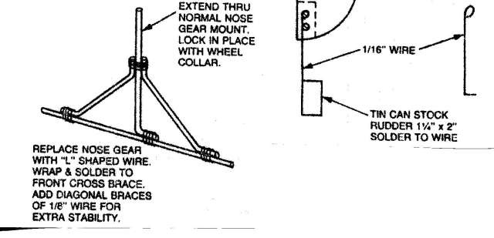

Foam Float Core Construction
by Ironsides
[contributions from MAAC pilots Skip Pothier, John Hawkins, Gord Schindler, Jack Humphreys, Bill Shedden, Winnie Ambruch and Phil Peloquin]
Introduction
Before you start, it is strongly recommended that you read the overview on float flying entitled "The Basics of Float Flying". There are some concepts contained in this work that are essential to proper float design and installation. Perhaps the most critical is an understanding of the importance of the step and its relationship to the aircraft centre of gravity. If you get this part wrong, your plane will probably just become a fast airboat and never get airborne.
This article discusses the construction of foam core floats. They are the floats of choice because they don't sink. Built up floats with cracked balsa sheet have a tendency to fill up with water. Once the water hits the inner balsa there is little hope of repair. If the water gets into the float and you get airborne, then you will experience a very interesting test of your piloting skills as the water sloshes back and forth and takes the centre of gravity with it. How do we know - guess!
Caveat
Gord Schindler taught me the basics of foam core cutting. Bitten by the bug, Skip Pothier and I cut our first set of foam cores in my garage in late 2000. We learned a great deal from that tentative step. The following descriptions and diagrams are aimed at newcomers to the sport of float flying. The measurements given are not exact and are not intended to be used as "fool-proof" plans. Rather, the intent is to give insight as to how to approach the whole subject. The narrative gives an idea of what will work adequately. More experienced builders may have more elegant solutions.
Sources
You can obtain foam cores for floats from three sources. You can buy them pre-cut from a mail order house or a local hobby shop or you can make them yourself. For the sake of argument, it is suggested that the reason you make them yourself is for the pure joy inherent in any act of creation. In general, the floats you obtain through the mail or from your hobby shop will be of superior quality; the foam used will be something known as EPP (expanded polypropylene foam). This type of foam is made using very small, uniform beads and it is what is known as virgin foam. Of course, with the higher quality comes a higher price. The discussion that follows assumes that you want a set the floats that will work, that are inexpensive, and are relatively easy to construct.
John Hawkins of the Halifax Radio Control Club suggests that you might you check for floatation billets to get large pieces of foam? In some areas they are available in expanded polystyrene - bead board- and in extruded polystyrene as in the Dow™ line. You might be able to find a local building supply firm that will cut a billet of foam to the thickness you want. These 4' x 8' blocks come about 30-in. thick and are hot-wired to whatever thickness you designate. If a group from your club got together, you could order a block cut to the thickness you want. Look for "bead board" producers in your area.
If all else fails, an adequate type of foam can be obtained at any store that specializes in construction materials, such as Home Depot™. The material is the normal white insulating foam that comes in sheets of varying thickness and normally in sizes of two feet by four feet or four feet by eight feet. For most float projects, you will need foam that is six inches deep; unfortunately, that size is not common in construction material. Consequently, the best route to go is a 2-inch thickness using three laminations to achieve the 6-in. depth. The foam used for this type of insulating board is of fairly low quality, the beads are of varying thickness and generally are made from recycled material; consequently, it does not provide the clean cuts that one can obtain with EPP foam. But, given the fact that you are going to cover it all with balsa sheet, who will ever know?
Float Types
There are two basic float patterns that are common to radio control float flying. They are the Carl Goldberg™/Great Planes™ variety (left) and the classic EDO™ style (right).
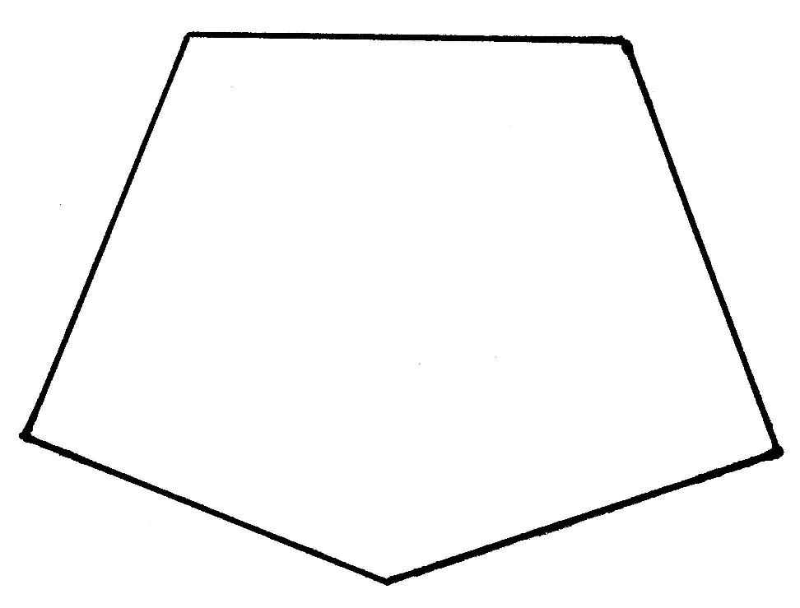 ......... 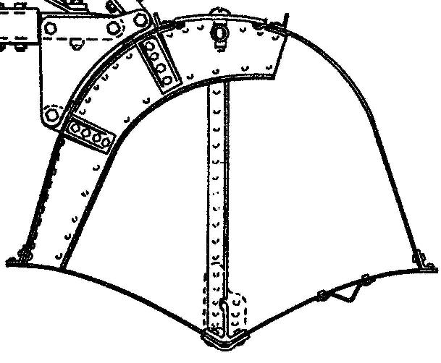
It is suggested that the EDO™ pattern is a bit more difficult and should be attempted only after the basic CG /GP™ patterns have been mastered. In our hobby, floats are sized to match two-cycle engine bores of 25, 40 and 60 cu. inches. The 40 size, or 36-in. length, is the most popular. The bulk of this article will assume that we are going to make the basic 36 in. CG /GP™ pattern. Afterwards, we will have a quick look at the EDO™ style.
Click here to jump to the EDO style.
Hot Wire Foam Cutter and Power Supply
It is beyond the scope of this article discuss the detailed construction of the power supply and cutter, but the basics for a bow can be found in a number of places on the Net - just do a "Google" search. Notwithstanding, this link might be of use:
http://webpages.charter.net/rcfu/ConstGuide/FoamWing.html
Assuming that you have now constructed your power source, the basics of the hot wire cutter should be discussed. You will need both a long cutting bow (44") and a short cutting bow (8") for foam core cutting. The type of wire to use it is called "nichrome" wire and can be obtained from hobby stores under the brand name SIG™ with a product code of SIGSH135. It is sold in lengths of five feet for approximately $3 Cdn. The longer bow is used to rough out basic blocks of foam, rather than using the band saw or carpenter's saw, while the short bow is used for the detailed form cutting. The long bow is also used to cut out foam wing cores (not covered here).
Templates
All hot wire foam cutting assumes that you have made templates that the hot wire will follow and melt the foam. There are many choices of material that one can use for the templates, only your imagination and cost are the limiting factors. At one extreme, we can use balsa sheet and at the other end you can use durable aluminum sheets for mass production runs. In between, one can use thin plywood or cheap pressboard.
The key to successfully foam cutting is ensure that the outside edges of the template are as smooth as possible. When you are cutting, it is extremely important to maintain a uniform speed so that the foam melts to a uniform depth. Any jag in the template will cause a momentary pause and/or jerk in the hot cutting wire that will leave a ridge in the foam. Equally, if you are using only sheet balsa as a template, you must ensure that the hot wire does not burn into the balsa.
Both these considerations can be met by covering the edge of the template with a smooth metal surface. At most hardware stores you can find smooth aluminum tape with an adhesive backing that is used to wrap around ductwork. You will have to cut these wider strips down to about 1/2" for our purposes. Winnie Ambruch pointed me to a more sophisticated method using the copper foil used by his wife in her stained glass hobby. It comes in long rolls in varying widths and has an adhesive backing. For our purposes the 1/4" width is best.
For the purist, the smoothest cut can be obtained by rubbing the shank of a candle on the foil surface before use. As the hot wire gets to the candle wax, it melts the wax and provides an excellent lubricant.
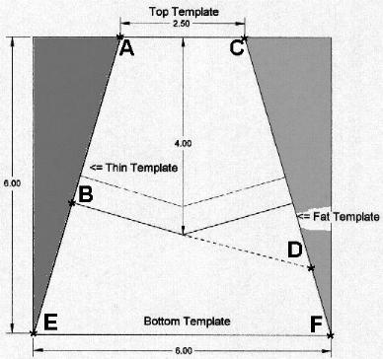
This will require us to make four basic templates and will involve several cutting operations. We started out with a 6-in. by 6-in. by 40-in. block of foam. An educated guess shows that the deepest measurement is 4-in. at the step. Using this key fact, you then have to determine the shape of the templates. The top one and the "thin side" ones are easy, simply trace the outline of an existing model, minus the thickness of any outer shell. The bottom and the "fat side" require some thinking. All is keyed to the size of your rough foam blank. If you go with anything other than 6-in. by 6-in, the following measurements will lead you astray.
The top template will follow the exact shape of the foam core that we wish to emulate. Since the foam core is going to be covered with1/16 thickness balsa, we must make the foam core 1/16 smaller than the finished product on all sides. Having traced out the shape of the upper surface we must now employ some of our high school geometry to figure out with the bottom template should look like. In essence, we have to project the sides to a shape that is considerably larger than that which we will eventually have left after the cutting has taken place.
In the diagram opposite, the width of the top template (A-C) is shown as 2.5-in. This is the actual size of the finished core. But, the bottom template (E-F) has to be a full 6.0-in. wide. Of course, that is much wider than the final core, but this is where the high school geometry comes in and forces us to take this preliminary step. The "thin side" template (A-B) will also be the actual size of the finished product, while the "fat side" template (C-D) will have to be oversized as shown.
If you are having a slow day, you and your buddies can while away a few hours debating whether the step on a 36 inch float should be mid-way at 18 inches or whether the split should be 17 up front and 19 in the rear. Your call!
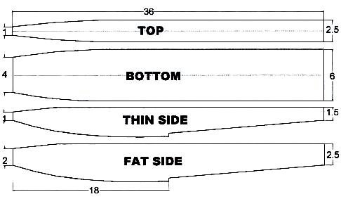
The measurements shown above are not absolute and are provided as a guide only. You can get a usable "fat side" by simply adding 1-in. to the girth of the bottom edge of the "thin side". If you want a more pronounced "Vee", then increase the girth of the "fat side". Note that the outlines of the tops of the "thin" and "fat" templates are identical.
Once you have your templates complete, you will need to drill a series of small holes along the centerline of each template. Into these holes we will insert 2-in. nails that will perforate the foam and hold templates in place while we complete our cutting.
Make sure that you place these nails such that they do not snag the hot wire when you cut.
Safety
The fumes generated when you use a hot wire to cut foam are hazardous to your health. Make sure you do the cutting operation in a well-ventilated place - it is not something that you want to do in your basement workshop - the smell alone will place great stress on your relationship with other family members.
Blank Cutting
You can use a band saw or a normal carpenter's saw to rough cut the basic shapes. You will find that the foam will create a lot of "dust" that has electrostatic properties that ensure that it will cling to every possible surface you can imagine and contaminate everything that you come into contact with for at least six months afterwards. By far the better route to go is the long hot wire cutter.
To start out, take sheets of white insulating foam that is two-in. thick, four feet wide and eight feet long. Take a yardstick and mark out blocks that are six inches wide by 40 inches long. We will need three of these basic blocks for each float.
We now need to laminate three of these 2-inch plates together. We must simply tack the three pieces together in such a way that the hot cutting wire will never come into contact with what ever material we use as glue. In essence we are going to run a bead along the 40-in. length, approximately 1-in. from the surface that we designate as the top of the float. We are going to glue them so that the pieces have the two-inch thickness facing upwards. The sheets need to be weighted down and left to cure overnight to make sure that the adhesive has set.
You can use epoxy, contact cement or foam glue for the lamination. Recently, I have been tending towards Probond©, which is one of the newer foam glues that reacts with water and expands to fill in any voids in the foam. Use this glue sparingly and wet both foam surfaces to get the reaction started. Watch out for the almost unnoticeable fumes - they are not good for your health.
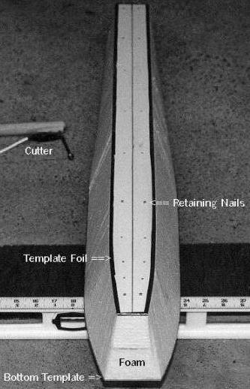
Core Cutting
Take the first blank that is 6-in. by 6 in. by 40 in. and put the top and bottom templates in place using the retaining nails. Looking from the side, there should be a completely smooth surface. That is, the top and bottom templates have covered the two sandwich lines.
Plug in your short hot wire bow and use a scrap piece of foam to adjust the power setting until the wire moves at a slow but steady pace. Only practice will tell you which temperature is best. If the wire is too cold, it will drag and you will get a very sloppy cut. If it is too hot, every time you pause for even a microsecond, the overheated wire will melt too much foam and you will have a very pronounced ripple effect.
Draw the bow in a smooth, continuous motion keeping the wire at 90 degrees to both template edges and ensuring that it stays in contact with both the top and bottom templates. You do not want any lead or lag of the wire - keep a constant chord.
Do not force the wire through the foam. Let it find its own pace. Without having actually measured it, my guess is that the wire covers one inch in the standard three count - one hundred and one, one hundred and two, one hundred and three. Perform this operation on both sides. You should wind up with the four-sided wedge shape shown at the right.
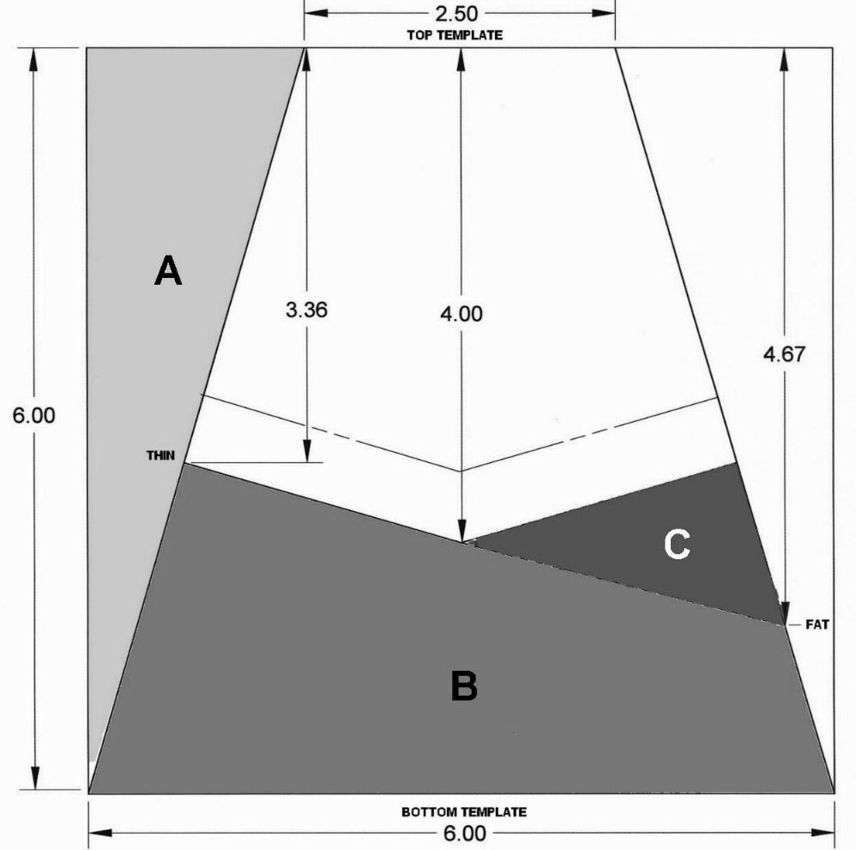
In rough numbers, it is about 2.5-in at the widest part of the top and 6-in. at the broadest part of the bottom. The wedge is 6-in. high front to back.
The first two first two cuts will have removed the material shown as "A" on the left side - and its mirror image on the right.
Now nail on the "thin and fat side" templates so that the top surfaces are flush with the top of the foam blank.
The "thin side" template is shown being 3.36-in at the deepest part of the step, while the "fat side" template is marked as 4.67-in.
Make your first side cut being especially careful to turn the corner at the step quite smoothly. This will remove the four-sided foam wedge at the very bottom shown as "B".
Now reverse the two side templates and make the fourth cut. It will remove the
If all went well, you now have a perfect "Vee" shape bottom the whole length of the float. The final cuts are at the front and back to adjust the 40-in. length down to 36 in. or what ever final length you desire, being careful to keep in mind the critical position of the step at the center of gravity of the aircraft.
Alternate Method
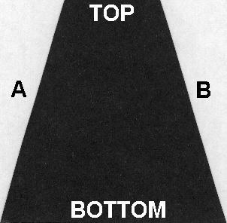
Like just about everything in life, there is more than one way to do things. John Hawkins of the Halifax Radio Control Club, which boasts a formidable float flying capability at Meisner Lake, has suggested another method.
Start out with a 6-in. by 6-in. by 40-in. blank. Using the same method as above, cut out the "wedge" shape using the top and bottom templates. John has a much more elegant term than wedge that reflects his Maritimes background - he calls it a tumblehome, which translates as, "the inward curve of a ship's topsides".
Note: All cross-sections shown are at the widest, deepest part of the step.
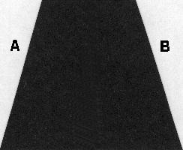
The great advantage of John's method is that the side templates are both the same size; to wit, the outline of the final shape you want. Ergo, there is less geometry involved - no need to calculate a "fat side".
Where side templates A and B are the same size, make the left and right cuts. The "tumblehome" will now be about 4-in. tall at the deepest part of the step.
Next comes the ingenious part.
Using your favourite method, cut the whole thing in half vertically, stem to stern.
Given the flat top and bottom, this could be accomplished with a band saw.
Equally, if you don't like flying foam particles, the long bow hot wire works well. You will have to make two templates that can be nailed to the front and back to given you are perfectly square line to follow.
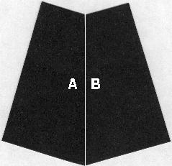
Using your foam glue of choice, reverse the two sides and glue the former outside edges A and B together.
Isn't that just the neatest trick?
Who would have thought of that in a month of Sundays?
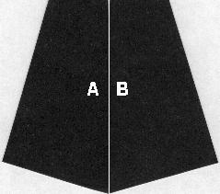
Finally, take the chevron-shaped top off to create a perfectly flat float.
Are there any other methods out there?
Attachment Plates
Regardless of the geometry of your undercarriage, it has to be attached to the float. The foam is too soft so we must use a 1/4-in. plywood attachment plate. It has to have enough surface area such that it will stay glued to the foam when subjected to shock and it has to be thick enough to hang onto the fastenings used. Those who have been flying for some time acknowledge the fact that they are going to crash. Equally, they have absorbed the lesson that tanks don't fly. That is, by the time you build up an aircraft to the point that it will not be hurt in a crash, it is so heavy that it won't fly.
Bindings
In the early days of skiing, those long planks were lashed to the skier's boot with leather thongs. When the skier crashed, the skis did not come off, the skier just broke a leg. Think of your float as a ski. It has a lot of surface area and is long enough to have quite a moment arm.
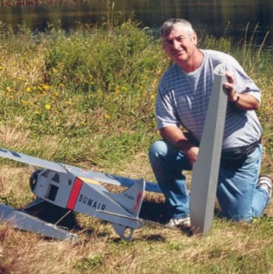
When you crash into the water at speed, something is going to break - all that is left is our choice of what we would like to crack first.
I would like the float to separate from the aircraft when push comes to shove. It is easier to fix a float than a wing!
So, you can nail your undercarriage to the attachment plate using wood screws. They are likely to rip out under force. Or, you can put blind nuts under the plywood and use 4-40 metal bolts. This combination is not as likely to tear out.
Jack Humphreys suggests that the best bet is to use blind nuts and nylon 4-40 wing bolts, as supplied by SIG™ part number SIGSH172. All things being equal, your biggest problem will be digging out sheered nylon shanks. (Tip: Take a flat edged soldering tip and melt in a slot in the nylon remainder and then unscrew using a small flat head screwdriver. If all else fails, bore out the nylon with a drill bit.)
If your undercarriage uses 5/32-in. wire, then a neat binding to use is nylon nose blocks and a central collet. Bill Shedden points out that you should grind the collet station flat on the axle to prevent "pops".
A typical binding will involve 4 blind nuts. To stop epoxy and/or contact cement getting into the nuts do this. Create circles using a paper punch and a scrap of covering film. Tack the circles to the bottom of each blind nut. When you epoxy in the attachment plate, the film will keep the epoxy out. Cut a piece of paper to the exact size of the attachment plate and use a pencil to mark the top of each nut. Cut strips of covering film about 4-in. by 3/8-in. and tack width-wise over the top of the nuts so that whiskers project over each side. When you lay in the top balsa sheet, the film whiskers will show the axis of the nuts, while the paper model will confirm the fore and aft locations. Use an awl to punch out the holes in the top balsa sheet.
Options
Like everything else in life, there are the basic and deluxe models. If you are just going to try float flying once or twice, then you can make up some basic floats. They may last a couple of seasons. The basic float is made by cutting the cores, sheeting them with balsa, gluing on some attachment plates for undercarriage and rudders then covering with film.
The cumulative effect of the buffeting from high speed on the water, and the odd missed landing, can cause a lot of sheer stresses that tend to open things up over time. More durable floats recess the attachment plates into the foam tops, use "rip away" mounting bolts, stiffen the rear deck, spread landing loads, use a step plate to protect the "Vee" and are covered with fibreglass to provide a durable cover. Bill Shedden prefers SIG Koverall©and dope to the fibreglass technique. Hereinafter, the optional features will be marked as such.
Stiffening Spline (Optional)
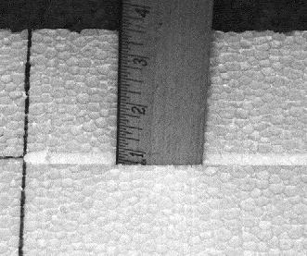
Some people believe that it is necessary to have a stiffener running down the rear two-thirds of the top part of the float. Some folks like to put in relatively heavy spruce wood strip that is 1 in. wide by 1/4-in. thick by 24-in. long. They lay in this spline so that the thickness is parallel to the top of the float. They use this thick horizontal spine as both the stiffener and a place to which one can screw in the under carriage bindings. This tends to be a relatively heavy installation, and adds weight to the rear of the float. Skip Pothier's much lighter alternative is to lay in a vertical spline of balsa wood that is 24-in. long by 3/4-in. deep by 1/4-in. thick.
We will discuss the balsa spline. This spline serves two basic purposes. First, it acts as the stiffener to prevent the back end of the float snapping off at the step, second it acts as a method of distributing landing load shock from the two under carriage plywood blocks. It is been noticed that after a couple years of flying that the landing shock creates absolutely incredibly small hairline fractures where two pieces of disparate materials meet. Small amounts of moisture seem to get into these cracks and, although you don't notice it immediately, over a period of time they cause the wood to swell and the crack enlarges. By dissipating the landing load shock it is hoped that these hairline fractures can be avoided.
There are three ways in which we can run the 24-in. long by 3/4-in. deep by 1/4-in. wide trench down the top back of the float. First we can use a router with a straight-line guide. This method is effective, quick and extremely messy. It is messy in the sense that you will be covered in particles of foam from head to foot. If you are lucky enough to own a table saw, then a couple of passes with a table saw will do a beautiful job with very little mess. Most likely the easiest method is to use a soldering iron with an existing tip running it down a straight edge and hoping that you can maintain a 3/4-in. inch depth.
A clever way of using a Weller™ - type soldering iron is to remove the existing solder tip and replace it with a length of 110-volt household solid copper wire bent in a square "U" shape of the trough that you want to cut out of the foam. The added tricks are to create templates or guides to give you straight lines and to control the depth of the cut. So, if you want to cut a trough one inch deep and your template/guide is 3/16" plywood, then the copper wire has to be 1 and 3/16 inches deep. It takes no time at all to cut a channel. Use masking tape to tack the template/guide to the foam while you are "soldering the foam".
Sanding
Because we are using the inexpensive insulating foam, the cut cores will be a bit rough. Take a sanding block with 80-grade paper and roughly sand off the sides. If there are any huge craters, fill them with lightweight vinyl spackling. Sand to taste, but as Skip indicates, you are going to paint on contact cement, so a mirror finish is not required.
Measurement
You will have to determine the stations on the top of the float where the front and rear undercarriage securing points will be located. Once this is been determined, cut out that mounting station as a square of 1/4-in. plywood such that it almost covers the top of the float side to side. In general, this piece of plywood is about a 1 3/4-in. square.
Cut out matching 1/4-in. notches in the stiffener to receive the plywood attachment plates.
Using the short hot wire bow and two scrap templates one each side, cut out a matching 1/4-in. deep saddle.
Before you glue in the stiffener, run a bead of thin CA down the 3/4-in. side of the spline to greatly increase its strength with paying a weight penalty. Use a thin coat of epoxy to glue in the stiffening spline into the rear 24-in. of the top of the float.
Glue the square plywood mounting platforms into the foam saddle such that the tops are perfectly flush with the top of the float. Allow the epoxy glue to set. Use a 1/16-inch balsa sheet to cover all four sides of the foam core.
Adhesives for Balsa Sheeting the Foam Cores
There are four basic ways to attach balsa to foam. Two of these methods are best reserved for sheeting wing cores, while the others work well for float cores. Sorghum gum is the proven, ancient and honorable way. Epoxy is an equally proven solution. However, both of these methods assume that you are going to be able to cover the sheeting material with the discarded foam saddles and then apply uniform weight for a protracted period of time (overnight). Vacuum bagging is a superior method to weight. The complex, four sided cuts of the float cores do not leave good matching saddles and the uneven and rounded surfaces make it very hard to weight the sheets down overnight - an easier solution is recommended. Use contact cement.
Contact cements come in three basic flavours. Paint-on water-based or solvent-based, and spray on. Solvents are not good for your health in poorly ventilated spaces - since they also eat foam, they are rejected. There have been reports on the Net that the spray-on contact cements (such as 3M 77™) can cause the balsa to delaminate in the hotter temperatures of mid-summer.
In essence, Lepage's™ water-based contact cement is the logical winner. It is easy to find, inexpensive, dries fairly quickly, doesn't stink up the house, gives a good bond and cleans up easily. Who could ask for more?
Balsa Sheet Laminations
If the sides are bigger than the width of your balsa sheeting, it is import to make up the laminations before you sheet. Lay the two pieces side by side on a perfectly flat surface - glass is a good choice. Cover the surface with waxed paper. Make sure the two sides line up exactly. Sand the sides with a long sanding block until you have a perfect mate. In the worst case, overlap the two sheets and use a steel edge to cut through both surfaces at once. Once the sides are true, you can use either thin CA or carpenter's glue to complete the job. Weight the sheets down so they cannot move. In either case, glue from the side that will be towards the foam core - you do not want a hard glue scab on the outer surface, as it is hard to sand and will result in an uneven finished surface. Be especially careful with thin CA - if it wicks through to the outer side, it will form a sheet of concrete that just cannot be sanded. There is no preferred sequence for covering the sides.
Cut the balsa sheet to a slightly larger piece than is required to cover the surface. Brush the contact cement on the foam and onto the balsa sheet. Allow both surfaces to dry as per the instructions. Carefully place the balsa sheet on the foam surface. Note that we will have only one try as the contact cement will grab the balsa and it is impossible to take it off without cracking it. Trim the oversize balsa with a razor knife so that the edges are flush with the foam core. Attach the other surfaces in sequence until all for sides have been covered. Leave the front and back ends bare for the moment.
Rear Plate
Take the back and of the float and traced the outline on a sheet of light ply. The light ply should be about 1/16th inch thickness. Use a hobby knife or coping saw to cut out this rear plywood shape. Attach it to the back the float with contact cement. This plywood is needed to secure the screws that will be used for the rudders.
Nose Blocks
The noses of the float will be covered with a block of balsa wood, but before we finish the float we need to have some idea of how the whole affair balances against the centre of gravity of the aircraft with floats mounted. We will be adding lead weight, probably to the noses of the floats and we will then conceal this lead weight by hollowing out the balsa blocks that we will eventually sand to a desirable shape. [Hint: Gouge out the foam at the float tip and glue in the butt of a plastic top of a CA cover. Add small fishing weights until balance is achieved, using cotton wool as a temporary plug. When satisfied, remove the cotton wool and pour in epoxy to secure the load. Glue on the hollowed out balsa nose to conceal.]
Attachment Plate Anchor Dowels (Optional)
When you come in for a landing, as soon as the floats touch the water a tremendous amount of drag is induced. That translates into a sheer force that wants to send the attachment plates to the back of the float and also tends to introduce a rotational force that wants to lift the plates off the float. Over time, this can introduce micro cracks. Both Phil Peloquin and Skip Pothier recommend that you install anchor dowels to avoid this.
Figure our where you will insert your undercarriage screws or bolts and look for some space where you can drill down 1/4 or 3/8-in. vertical shafts. Depending on your choice, you can use two to four of these dowel receptacles. The shafts should be 1 1/2 to 2 inches in depth. After you have epoxied the attachment plates onto the float, epoxy these anchor dowels in place. They will make sure that the sheering forces do not dislodge the attachment plates.
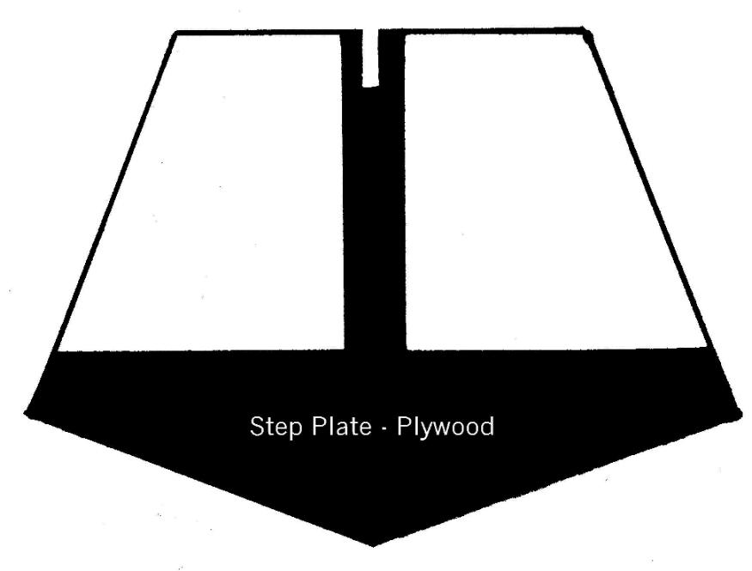
Step Plate (Optional)
As Phil Peloquin points out, when all is said and done, it all happens on the step. This area takes the most punishment and some reinforcement might be appropriate. The simplest method is to insert a light plywood step plate.
Place a carpenter's saw against the vertical surface of the step with the saw teeth up. Cut a narrow slot up into the float about one inch deep at the "Vee" of the step. Take a piece of paper and insert it into the slot. Trace out the pattern.
At the top centre opposite the "Vee" point, put a 1-inch vertical tongue on it. Notch the top of the tongue so that it will mate with the 3/4-inch balsa stiffener. Transfer the pattern to light plywood that matches this shape and epoxy it in place.
Anti-Crush Panels (Optional)
Bill Shedden likes to build bigger planes. With the heavier weight, there is the concern that sitting the plane on the ground will lead to damage to the float bottoms where the weight is concentrated, namely the step. Equally, when start or we tinker with engine, we tend to lean on the aircraft: all such forces transfer down to the step area. Bill likes to put in lite plywood panels that are about 2-in. wide, extend the width of the float, are just forward of and tie back into the reinforcing step plate. These panels replace about 2 inches of balsa sheet.
Steering Control Guides (Optional)
You might need to sink a couple of 1/4-inch dowel plugs into the rear deck of the floats to install small metal guides for steering rods or cables. Epoxy them in before you cover the top deck with balsa sheet.
Covering
If electing to cover with fibreglass cloth, this procedure is explained in depth in the separate article entitled,
"In Praise of Water-based Polyurethane Varnish".
EDO Style Floats
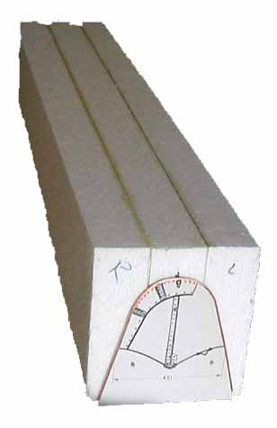 | 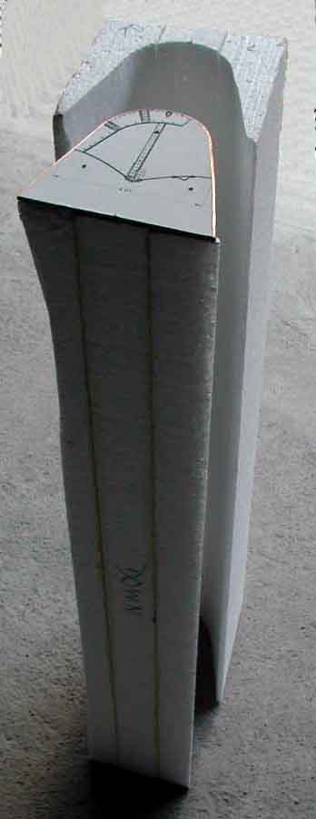 | 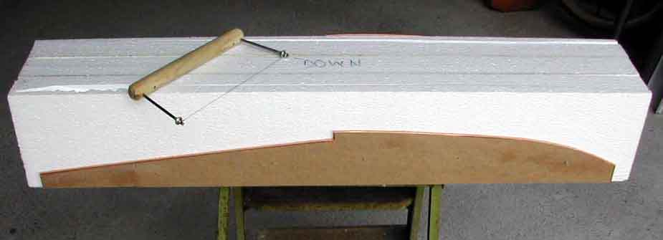
The fundamental difference cutting this style of foam core is the very first step. Templates of the same size and shape are nailed to the back and front of the foam core blank. The hot wire is run around the templates to cut out the equivalent of a "railroad tunnel". The "railroad tunnel" is tacked back onto the hump shape and the fat and thin side templates are tacked onto the outer sides of the "railroad tunnel".
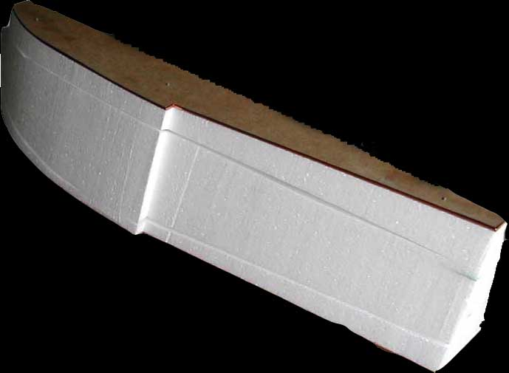 | 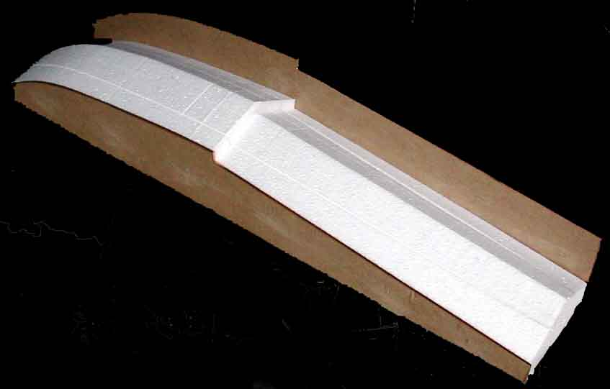 | 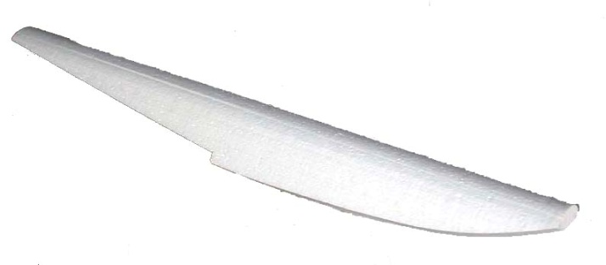
Once the first cut is made, the fat and thin side templates are reversed and a second cut made to get a perfect "Vee". The result is shown above.
Click here to return to the Carl Goldberg style.
Overview of Setup and Flying
You cannot go wrong by having another look at the article, "The Basics of Float Flying". This prose summarizes the collective wisdom of those who have already made all the mistakes and are busy inventing new ones!
Detailed Guide by Skip Pothier
Having taken you through all the above, let me admit that Skip has done a much better job at explaining the nitty-gritty in a very well-written article that you should read. Skip assumes that you have a pair of foam cores, then leads you through the steps to finish a perfect set of floats. Click here to read his work entitled, "Building Those First Foam Core Floats".

THE BASICS OF FLOAT FLYING
by Ironsides
[with contributions from Skip Pothier, John Hawkins, Gord Schindler, Bill Johnson, Walter Lawrence and Art Schmitz]
Introduction
Flying off water brings a new dimension. Usually the scenery is a lot more pleasing and the noise levels seem to be much lower. The type of pilot who flies off water is usually a pretty calm type of person and water sites are usually a bit more remote and picturesque. A lot of spouses will go to a fun float fly whereas they wouldn't dream of attending a field setting. It is more like a picnic at the lake.
There is a mistaken belief that it is a lot harder to be a good seaplane pilot. Actually, once you get the hang of it, flying off water is usually easier. Just think, the runway is very long, wide and flat. Equally, there are no balsa magnets just beyond the grass waiting to snare your plane. The aim of this article is to take some of the mystery out of the hardware and techniques of this unique pleasure.
Type of Plane
There are two basic types of planes that fly off water. Float planes, that are usually converted wheeled aircraft, and flying boats that have a boat-like hull. The planes shown below have glow engines.
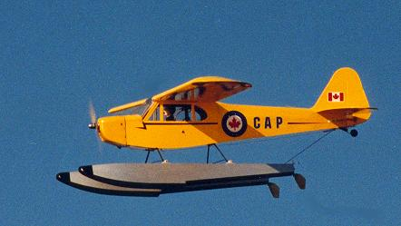 ... 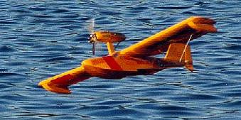
Cub by Skip Pothier Seamaster by Ted Curl
Flying Boats
Model flying boats have three major points to check. If the engine is mounted on a pod above the wing, it might need as much as 3 degrees of up-thrust to achieve balanced performance. Notwithstanding, designs like the Seadancer, Seamaster and Sea Cruiser have a neutral thrust line.
The floats at mid-wing or wing tip can present a problem if they have too little buoyancy and/or they are too narrow - in both cases they will tend to dip under the water and cause the plane to go in circles due to excess drag.
While some seaplanes with low stabilizers work well, T-tails or mid-fin stabilizers are usually best to prevent the stabilizer from hitting the water under less than ideal conditions.
If you can afford a dedicated water bird, then a flying boat design is much easier to handle and does not require any significant increase in engine power to overcome the drag that floats and attendant rigging induce. Flying boats are significantly more aerobatic than float planes in that they don't have the extra large mass under the fuselage to cause "pendulum effect". Finally, they can handle higher winds on the water better than float planes.
If you are a novice, don't try to pick the plane that looks nice in the catalogue. Ask experienced pilots which design works best for your situation.
Electrics
Electrics really come into their own on water as multi-engined planes are relatively easier to handle than their glow-powered equivalents. Those with sharp eyes might detect that the CL 215 has no water rudder. Steering on the water is handled by adjusting the thrust of each engine!
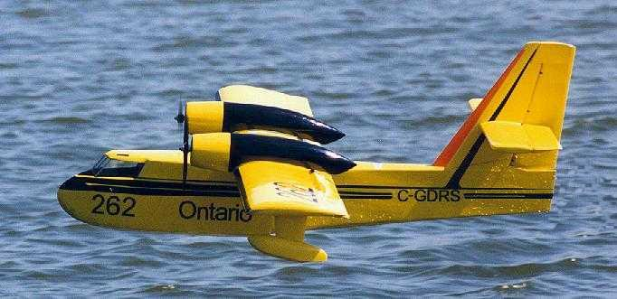.........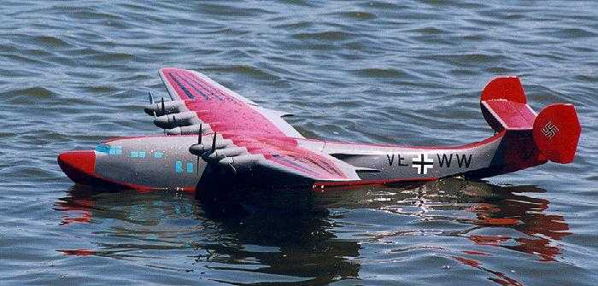
CL-215 by Robert Pike Potez-Cams 161 by Laddie Mikulasko
From a beginner's point of view, the flying boat is easier to handle. However, most beginners want to dip their toe in the water just to see if they like it; therefore, it is usually easier to convert an existing wheeled plane. For the remainder of this exercise, only float planes will be discussed.
Overview
So what are the things to consider. As an overview, the list is:
* you need to choose which type of airplane to convert
* you need some floats
* you have to construct the mounting gear for the floats
* you need about 20% more power to overcome the water friction and suction
* you want raw hauling power rather than top speed - lower the pitch of the propeller
* you should waterproof critical components
* you need to determine the step position
* you have to adjust the relative angle between the floats and the fuselage datum line
* you might need to add a ventral fin to increase fin area
* you need water rudders for on-water taxiing.
* you need a place to fly with a recovery boat
* you need to learn a little plane handling technique
Type
Just about anything can be made to fly off water on floats, even a real Supermarine Spitfire. However, most models that you see are more sedate. Cubs are the single most popular choice, followed by the venerable Beaver and Norseman. Basically, a flat bottom or semi-symmetrical airfoil type is best for beginners.
All things being equal, it is desirable to choose a plane with a slow stall speed as this eliminates a bit of risk if you take off too soon.
As a first effort, you might well want to take your trusty trainer, although you probably will want to increase the horsepower.
Floats
There are three ways to acquire floats. You can buy pre-built plastic floats from the hobby shop. Equally, you can buy kits to create built up floats (hollow) out of balsa and light ply. Lastly, you make your own starting with a foam core that is covered with balsa sheet and finished with either film covering or fibreglass, epoxy finishing resin and paint. The choice is yours, but the aim is to get something that has enough buoyancy for the weight of your plane and to remain leak proof even when submitted to a bit of punishment.
Float Cradle
With the exception of the plastic floats, the bottoms of your floats are quite soft and easily damaged. A cheap and simple idea is to build a float cradle. Take four pieces of wood about 3/4 inch square. The width needs to be about six inches wider than your floats, while the length is just an eye appealing symmetry. Assemble the wood in a square with the two width members on top. We need to nail the pieces together so that the nail heads protrude about an eight of an inch. Drill a hole at the four intersections to accept the nail and to prevent the thin wood from splitting. Push three quarter inch foam water pipe insulation over the two width members. Put carpenter's glue or epoxy on the four corners and insert the nails. Clamp and let dry.
When transporting the aircraft, put the cradle in the back of your vehicle on a piece of carpeting or use the vehicle carpeting. Lay the floats on the foam to prevent damage. At the flying site, use the foam cradle when you are working on your aircraft.
Engine
Both 2 cycle and four strokes work well. The 2 cycle is lighter and may be more practical for smaller models. It is also less prone to damage when it eats water. The four stroke has the low end torque that is so useful for float flying. Nothing sounds better over water than a four stroke.
In both cases, you will need about 20% more power than the equivalent wheeled requirement. As a rule of thumb, go one size bigger. So, your 40 powered trainer will need a 46 to get off the water.
Some people advocate adding a safety wire to the engine so that it does not sink to the bottom of the lake if the engine is torn off in a major crash. This seems to happen more to aircraft with the engine mounted in a slender pod above the wing. The idea is to secure one end of a braided wire tether to something fairly solid that will survive a crash, and the engine mounting bolts to the other end.
Propeller
As a general rule, never use wooden propellers when flying off water. They will shred almost instantly when hitting water. Advanced flyers know how to paint wooden propellers with epoxy finishing resin that then makes a wooden propeller feasible. For most applications, a solid plastic propeller, such as the APC brand, works well.
You will find that dropping the pitch one size will give you much better lift off capability.
Propeller Tip Clearance
We do not want water sucked up or splashed up into the propeller disk. As a rule of thumb, make sure the propeller clears the top of the floats by one inch or more.
If you find a clearance problem, you could change to a three-bladed propeller. Usually, a ten-inch diameter three-bladed propeller would replace an 11-inch diameter two-bladed propeller.
Splash Rails
To minimize spray hitting the propellers, some like to install splash rails on the tip of the floats, from the nose back to the propeller line. These rails need only be on the inside edges. A one-third inch wide strip of clear plastic sheeting embedded roughly parallel to the water, following the curve of the float and fixed into the float body with epoxy seems to work well.
Waterproofing
Most glow engine aircraft are pretty waterproof, but there are some special considerations. When a plane tips over in the water, it generally comes to rest with the engine submerged and the fuselage pointing skyward at a 60 degree angle. Water tends to creep in through the wing saddle and the canopy.
You should paint exposed balsa in the fuselage cavity with varnish to make it waterproof. You need to wrap your receiver in plastic to prevent damage. One ingenious method is to take a rubber surgical glove, nick holes in the ends of the fingers and thumb, pass the servo leads and antenna through these perforations, seal up the small holes with waterproof glue and place the receiver in the palm of the glove. Tightly wrap a rubber band around the wrist of the glove and encase the package in latex foam rubber. Caution: Do NOT use silicone sealant as it contains chemicals that attack electronics.
Caution: Do not wrap your NiCad battery pack in any impervious material. First, any watertight wrapping will cause the battery to overheat when you charge it and damage will result. Second, there is a small vent hole in a NiCad cell that allows gases to escape - a vapour barrier will trap these gas and lead to cell deterioration. The battery pack, wrapped in the normal latex foam vibration absorber will be waterproof enough for our purposes.
Where the wing mates with the fuselage, you must take some steps to keep the water out. There are three common methods to accomplish this. Along the line of the wing saddle, you could glue a thin rubber, ribbed weather stripping commonly found in hardware stores. Alternatively, you might laying down a bead of silicone sealant on the saddle and drop the wing (covered with plastic wrap) onto the saddle, let the bead dry and remove the plastic once the sealant has cured in the desired shape. A third method is to simply put the wing on, sealing the gap with a bead of Vaseline.
Rudders
In anything less than the lightest breeze, it is impossible to control the taxiing of a float plane on water. You will need rudders and two are always better than one. The rudders should be rigged for maximum deflection left and right, as steering at low speeds will require the extra bite. You can buy Ernst plastic rudders in 40 and 60 size. You can easily make your own out of thin metal.
Rudders should swing upwards out of the water for two reasons. First, as you approach take-off speed you do not want rudders to have any steering effect, nor drag for that matter. Second, when you taxi back to the beach, you want the rudders to fold back to prevent strain on your steering set-up.
The water rudders have to work in harmony with the air rudder. The easiest and cheapest rig is to put a double barred servo arm on the rudder servo. That is, the arm length is equally long on both sides of the pivot point. Tie two lengths of light nylon fishing line to each side of the servo arm. Glue a small length of fuel tubing into the bottom of the fuselage, canted towards the rear.
On the top of the floats, about twelve inches from the rear install small metal guide loops. On the water rudder steering arms, attach four nylon clevises. Bring the four lines out through the tubing, down through the metal guide loops and thread them through the appropriate clevis on the water rudder steering arms. Ram a piece of wooden toothpick into the clevis neck to secure the line. Tighten the fishing line and test the water rudder movement. When all is smooth, put a drop of thin CA on the wooden toothpick to secure the line. Cut off any extra line.
An alternative, which makes it quick to change from water to land gear, is to drive the rudder with a separate ball link from the rudder horn, with either a piano wire directly to the rudder or with a sleeve and cable run under the fuselage and looped back along the top of the float to the rudder horn. Dual rudders can be linked with a cross rod.
Larger applications may require a servo mounted directly on or recessed into one float.
Ventral Fin
A plane with a long enough tail moment and large enough tail feathers can get away without a ventral or sub-fin. That is why Cubs and most trainers are nice. More scale type aircraft, such as a Beaver, are short coupled and usually need the fin. Why?
The floats add a huge slab of hull that reacts against side winds. The effect can be so bad that the plane literally forgets which way is forward and starts to weathervane into the side wind. This can be prevented by adding a removable ventral or sub-fin on the bottom of the fuselage under the existing fin. This will increase the effect of the tail feathers and keep the plane going in a straight line.
Another trick, but more permanent, is to add small finlets to each side of the horizontal stabilizer. This also increases the area of the fin.
One indication of inadequate tail moment is to taxi downwind and reduce to idle. If the plane doesn't turn its nose into the wind, the vertical fin area isn't big enough and a ventral fin should be added.
The Step
The step is that notch in the bottom of the float. If you look carefully, you will notice that the bottom of the hull slopes upwards at about 3 to 5 degrees behind the step. This allows you to rotate the aircraft for take off and landing without the back of the float digging into the water. If the rear of the float drives down into the water, drag will increase and no lift-off will occur.
As the aircraft increases speed on take-off, the float rides up onto the step and a huge amount of suction is eliminated. Nothing is more important than getting the step in the right place.
In general terms, the step should be under the centre of gravity or about one half an inch to the rear of the centre of gravity.
Balance
When constructing your floats, you should try to get them to balance at the step. The step will subsequently be positioned close to the centre of gravity of the aircraft.
If the centre of gravity of your "wheeled" aircraft changes when the floats are added, always add the balancing lead to the nose (or tail) of the floats for two reasons.
First, the noses (tails) are furthest out and provided the greatest leverage for the least amount of lead. Second, when you take your floats off and go back to wheeled flying, you won't have to rebalance the plane.
Attachment Gear
You have to decide whether you are going to retain the existing wheeled landing gear and adapt it to the floats or whether you are going to take off the wheeled gear and create a totally new mount.
If you keep the existing landing gear, you will have to insert some hard points in the rear bottom of the fuselage at a point about half the chord width behind the trailing edge. These hard points will anchor a rear landing gear support that might be a bit lighter, but similar to the front gear. If you are going to strip off the landing gear, then you will need hard points front and rear and a solid support geometry to support the floats that does not twist or bend.
If you retain the landing gear, think of using nylon nose wheel steering blocks as quick mounts on the floats so that you can switch back and forth between floats and wheels quite easily.
Float Angles
This subject is very tricky, but is the cause of some maddening moments when float flying. There are some planes that simply do not seem to want to take off, even though everything looks right. That is because the problem divides itself into two major components. First, the static part that relates to the angle between the airfoil and the floats and second, the dynamic way in which the floats run on the water and affect the angle of attack of the airfoil.
The wing chord datum line (the line through the centre of the leading edge to the centre of the trailing edge) to the float datum line (for our purposes the line along the flat top of the floats) is static and is fairly easy to understand. In the case of flat-bottomed airfoils, these two lines need to be parallel. The simplest way to check this is to place a straight piece of wood under the airfoil, front to back, and check to see if it is parallel to the float top.
With other airfoils, the float tip angle can be about one or two degrees down from the fuselage datum line; that is, the distance from the wing leading edge to the top of the float is slightly more than the distance from the trailing edge to the top of the float. In rough terms, with most trainers, this usually means about one half an inch.
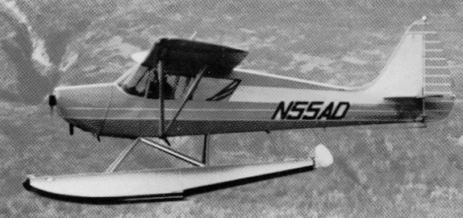
The aircraft in the photo above is a real Arctic Tern. Take careful note of the datum line running through the length of the fuselage and its relative angle to the line running along the top of the float. That works for this specific aircraft. Other aircraft do not require the same dramatic float tip droop.
With some airfoils and aircraft configurations, the incidence may have to be adjusted one or two degrees negative or positive for best results. Note that there is as much "art" as "science" to float flying!
Another school of thought suggests that setting the float tops at the same incidence as the stab works well. It is a simpler way to explain it. This holds the wing at the normal flying angle of attack and presents the floats at the least frontal area. Since the drag of the floats may require an adjustment of the Angle of Attack, in effect changing the stab incidence through elevator trim, it may be off a bit but probably no more so than other approaches.
Most fliers can stop right here, but for the problem cases a further explanation is offered. That is, we must also consider the dynamics of planing action on the water. Dynamically, during landing and take off, there is the wing incidence in relation to the planing level of the floats. Most particularly on take-off when the floats come up on the step, it has to be about 2 to 4 degrees positive. If it is too little, the plane will not take off. If it is too much, the plane will take off too soon and stall.
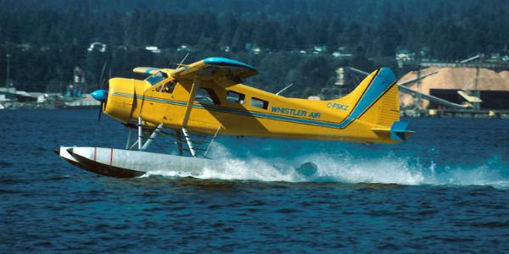
Photo by Stefano Pagiola
This angle will be affected by, among other things, the wing to float incidence, the size of the step, the length of the float behind the step and the degree by which the tail of the float diminishes towards the rear. This is the dynamic portion.
The good news is that you don't need to know most of this. Float designs, which affect the planning action, are pretty standard and take care of the complicated stuff. Just get the static angles right and make sure the step is in the right place. Most people flying standard models will never have to worry about the dynamic side of the equation. There will always be a local expert who can diagnose the problem plane.
Walter Lawrence, who cuts foam cores professionally, has published recommendations indicating that high wing planes have a static angle of 1 degree positive, while mid-wing and low wing machines set up at 0 degrees to the floats.
Going back to high school trigonometry, if the wing chord (the line running from leading edge centre to trailing edge centre) is 10 inches, then the tangent tables for 1 degree (10 times 0.01746) suggest the leading edge is further from the float tops by 0.1746 inches than the trailing edge, or with a chord of 12 inches, 0.2095 inches. The reader is left to deduce how many popsicle sticks make up these fractional amounts.
Float Nose Protrusion
The noses of the floats need to protrude beyond the propeller anywhere from one half to one third the diameter of the propeller. Thus, if you are swinging an eleven-inch propeller, the noses should jut out about four inches. This ensures that there is enough flotation up front so that when you apply throttle, the noses don't submerge and you don't get into RC submarine operations.
Flaps
If ever there was a time to put flaps on a plane, it is for flying off water. Flaps make take-offs and landings so much easier that it is hard to sing their praises loudly enough.
Flying Technique
When flying off water you must become much more aware of the wind. It affects taxiing as well as take-off and landing. Left alone, a plane on water will always weathervane into the wind. If the wind is too strong, you may have no control other than going straight into wind. You can use the weathervane effect to your advantage. To get lined up for a takeoff into wind, taxi out and then drop to a very low idle. The wind will line you up automatically!
Taxiing becomes a little like sailing; you must judge your turns according to the strength and direction of the wind. Flat bottom, high wing machines are notorious for flipping over if you let the wind get under the wing when turning down wind. You must learn to use aileron to lean the plane into the wind. Even with the engine off, the wind can be used to "sail" the plane back to shore. You might need to talk to a sailor to understand this notion.
Always take off and land into wind. With a wheeled aircraft taking off from the grass, you can get away with cross wind techniques. Those large, draggy floats and the extra weight make it very tricky to take off cross wind. It can be done, but the tendency is for the plane to lift off and immediately cartwheel into the water on the down wind side as that float will still be in the water creating drag when the upwind float is airborne.
Local shoreline configurations, tall trees or buildings can change wind patterns quite dramatically. It is a natural tendency to assume that the wind is 90 degrees to the parallel line of waves. Be very aware that this is often not the case. Make sure you have a small piece of light yarn on the tip of your antenna to act as a "tell tale" as to probable wind direction - then again, be conscious of the fact that what you see at your antenna tip is not a guaranty of the actual wind at your take-off point. Watch other flyers taking off and observe any tendency to roll to one side on take-off. The roll will be to the downwind side.
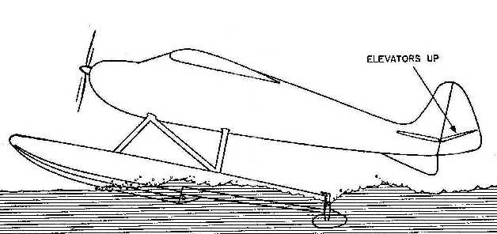
When taking off, taxi to position using the rudder. When lined up, apply full up elevator and apply throttle. The object is to get the floats lifting up onto the step. As soon as you see the plane up on the step and an increase in speed, relax the elevator to neutral. As you approach full speed, try not to use rudder at all, and if you have to, do it sparingly. Too much rudder and the float tip on the inside of the turn will dig in and you will flip before you know what happened. Close to full throttle, gently apply up elevator until the floats leave the water. Then level out to gain airspeed before completing the climb out.
On the take-off run, two forces can cause the plane to go airborne. Hydrodynamic forces, caused when you hit a wave, can launch your plane before it is ready to fly aerodynamically. The craft will stall and cartwheel into the water. Hence, be careful not to have any up elevator on until the plane is almost ready to fly.
Landing a float plane is easier than a wheeled plane. First, the runway is very long and second it is very flat. Just line up and ease back on the throttle to set up a shallow, sinking approach that is a bit faster than the land version. The extra weight of the floats will make it stall earlier and the increased drag will cause the plane to slow down more quickly. When over the threshold, ease back on throttle and hold it off about three inches above the water. It will land itself. Taxi back using aileron and elevator to balance any strong wind.
Crashing
When you crash on water, the structural damage is usually less severe than hitting terra firma. Water damage is a major concern; but, provided you waterproofed reasonably well, it is just a matter of swallowing your pride, getting the recovery boat and picking up your wayward friend.
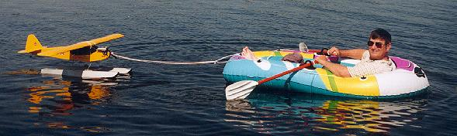
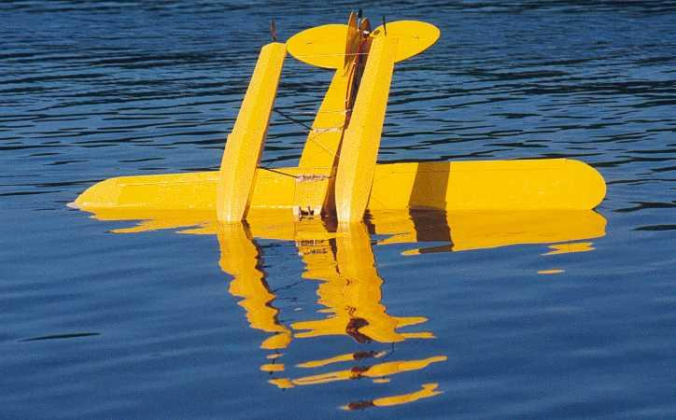
Usually your craft will be floating upside down on its wing, with the engine submerged. Often, a small amount of water will leak into the upper wing saddle cavity. NEVER, NEVER, NEVER turn the craft right side up. The water will drop down inside and dampen all that is still dry. Turn off the receiver and get the plane back to land upside down, take off the wing and let all the water drain out.
The engine will have ingested water. The piston will now be in hydraulic lock. You cannot compress water and if you try to turn the shaft you will probably snap the connecting rod. Simply take out the glow plug and let the water drain out. Squirt a bit of fuel into the cylinder and flood the case through the carburetor. With the glow plug still removed, turn over the crank by hand and make sure the muffler drains as well. Setting the plane right side up, you can then give the crank a whirl with your electric starter, making sure to keep your eyes out of any spray coming from the glow plug hole. While all this is going on, you can hook your glow plug up to its electrical driver to dry it out. Put in the glow plug and start the engine as soon as possible. The heat from the combustion will purge all water and the lubricant in the fuel will coat the bearings. The worst thing to do is nothing and let water rust the bearings.
In June 2001, four more valuable lessons were learned. The Beaver on floats was deliberately put into an inverted spin, but would not come out - only the rudder was having any effect. It hit the water going straight down. The windshield blew out and the fibreglass cowl exploded - imagine going off the high board with your mouth open! All was repaired in a couple of days. But, the impact was so hard that the clunk was driven to the top forward part of the tank and the glow element bent into the plug wall thereby dissipating the heat from the element.
Lessons learned:
1. Drain the tank and shake the plane to make sure the clunk is free.
2. Examine the glow plug coil to make sure the helix is still centred.
3. The pendulum effect of floats makes extreme aerobatics tricky. Go high - really high!
4. If it had hit land, the Beaver would have been balsa dust - crashing into water can be safer!
If your receiver got wet, do not mess with it. Take off any wrappings and lay it out in the sun to dry. If it got really damp, your day may be over. Never fear though, once dried out, it will be just fine. However, if you were flying off salt water, the news is probably very bad. The saline solution will damage the electronics very quickly.
Fuel Supply
Something to remember is the fact that low fuel level in the tank will allow the clunk to become uncovered when touching down on rippled water. It is better to land with a third of the tank full to prevent fuel slopping and subsequent engine failure - followed by that long row of shame to retrieve your plane.

